**Experiment Number : 3 Date: 03/02/25**

## **Demonstrate JSON File Data Read and Write Using Node.js**

### **PRE LAB EXERCISE**

**QUESTIONS:**

1. **What is JSON?**

JSON (JavaScript Object Notation) is a lightweight, text-based format for storing and exchanging data. It is easy for humans to read and write, and easy for machines to parse and generate. JSON is commonly used for transmitting data in web applications between a server and a client.

{

"name": "John",

"age": 30,

"city": "New York"

}

1. **How do you read a JSON file in Node.js?**

**Using fs.readFile() -** fs.readFile('data.json', 'utf8', (err, data)

**Using fs.promises.readFile() (with Promises) -** fs.readFile('data.json', 'utf8')

**Using require()** (for JSON files in the same directory) - const jsonData = require('./data.json');

1. **How do you write data to a JSON file in Node.js?**

Using fs.writeFile()

Using fs.promises.writeFile() (with Promises)

1. **What is the difference between synchronous and asynchronous file handling?**

**Synchronous:** Blocks execution until the task completes. Slower but simpler to handle.

**Asynchronous**: Non-blocking. Allows other tasks to run while waiting for file operations to finish.

**Performance**: Asynchronous is faster and more efficient for large tasks.

**Error Handling**: Synchronous uses try-catch, while asynchronous uses callback error handling.

### **IN LAB EXERCISE**

#### **OBJECTIVE:**

* To read and write JSON data using Node.js file system module.

#### **RESOURCES:**

* Node.js installed
* JSON file

#### **PROGRAM LOGIC & IMPLEMENTATION:**

1. Create a JSON file (data.json).
2. Read the JSON file and display content.
3. Modify the JSON content and write back to the file.

### **PROGRAM: JSON Read and Write in Node.js**

#### **Step 1: Create a JSON File (**data.json**)**

{

"name": "Alice",

"age": 25,

"city": "New York"

}

#### **Step 2: Read and Modify JSON (**jsonReadWrite.js**)**

const fs = require('fs');

fs.readFile('data.json', 'utf8', (err, data) => {

if (err) {

console.log('Error reading file:', err);

return;

}

let jsonData = JSON.parse(data);

console.log('Original Data:', jsonData);

// Modify JSON data

jsonData.age = 30;

fs.writeFile('data.json', JSON.stringify(jsonData, null, 2), (err) => {

if (err) {

console.log('Error writing file:', err);

return;

}

console.log('Data updated successfully');

});

});

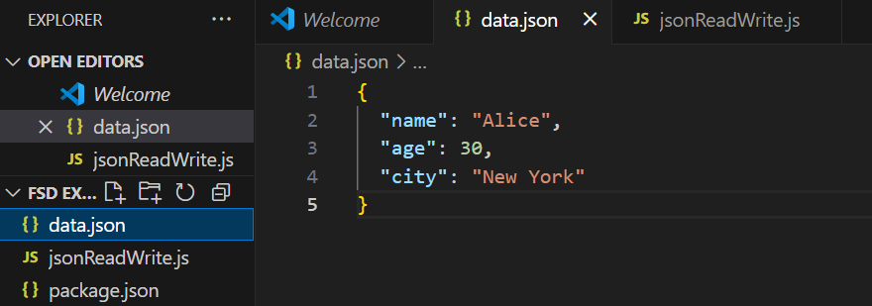

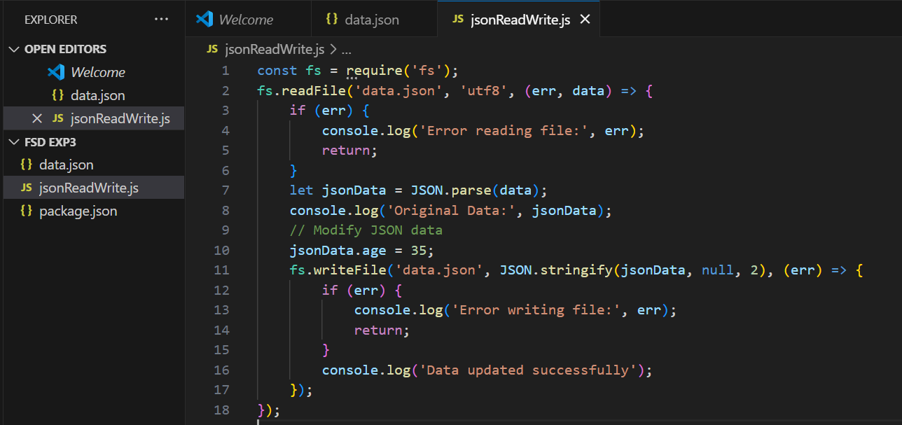

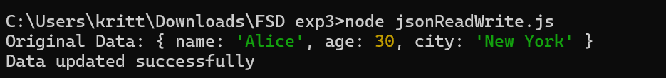

### **POST LAB EXERCISE**

1. **What method is used to parse JSON data in JavaScript?**

The method used to parse JSON data in JavaScript is JSON.parse().

const jsonData = '{"name": "John", "age": 30}';

const obj = JSON.parse(jsonData);

console.log(obj.name);

1. **Modify the program to add a new key-value pair to the JSON object.**

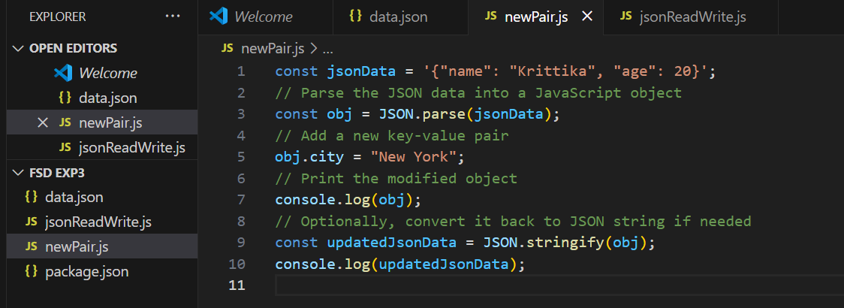

1. **How would you handle an error if the JSON file is incorrectly formatted?**

To handle an error if the JSON file is incorrectly formatted, you can use a try-catch block when parsing the JSON data. This way, if there is an error during parsing (e.g., due to incorrect formatting), the program will catch the error and handle it gracefully.

const fs = require('fs');

fs.readFile('data.json', 'utf8', (err, data) => {

if (err) {

console.log('Error reading the file:', err);

return;

}

try {

// Attempt to parse the JSON data

const parsedData = JSON.parse(data);

console.log(parsedData);

} catch (error) {

// Handle JSON parsing errors

console.log('Error parsing JSON:', error.message);

}

});

1. **Explain the difference between JSON.stringify() and JSON.parse().**

**JSON.stringify():** Converts a JavaScript object to a JSON string.

JSON.stringify({name: "John"}); // '{"name":"John"}'

**JSON.parse(): Converts a JSON string to a JavaScript object.**

JSON.parse('{"name":"John"}'); // { name: 'John' }

**ASSESSMENT PATTERN.**

|  |  |  |
| --- | --- | --- |
| **Description** | **Max Marks** | **Marks Awarded** |
| Pre Lab Exercise | **5** |  |
| In Lab Exercise | **10** |  |
| Post Lab Exercise | **5** |  |
| Viva | **10** |  |
| **Total** | **30** |  |
| **Faculty Signature** | |  |